SIMATS ENGINEERING (SAVEETHA SCHOOL OF ENGINEERING)
Department of Computer Science and Engineering
ASSESSMENT TOOL 2 – Industry Problem Solving Task
Course Code: | CSA06 | Course Title: | Design and Analysis of Algorithms
CO Assessed: | CO4: Articulation (BL4, BL5) | Assessment: | Assessment Tool 2 – Industry Problem Solving Task
Weightage: | 20% of CIA | Total Marks: | 100 (2 Questions × 50 Marks)
CO4 Statement: | Solve optimization problems using dynamic programming and greedy strategies.
Student Name: | S.MAHALAKSHMI | Reg. No.: | 192524372
Section / Batch: | 2ND YEAR | Date: | 29/08/26

Instructions to Students
- Answer both questions. Each question carries 50 Marks. Total: 100 Marks.
- Carefully analyze the given questions.
- Explain in detail with sample code if needed.
- Clearly identifies all key issues.
- Thorough analysis with validated results and performance evaluation

Question Type | Description | Questions | Total Marks
Industry Problem Solving Task | Focus on Solving optimization problems using dynamic programming and greedy strategies | Q1 – Q2 | 100

SECTION A – Industry Problem Solving Task
QUESTION 1:
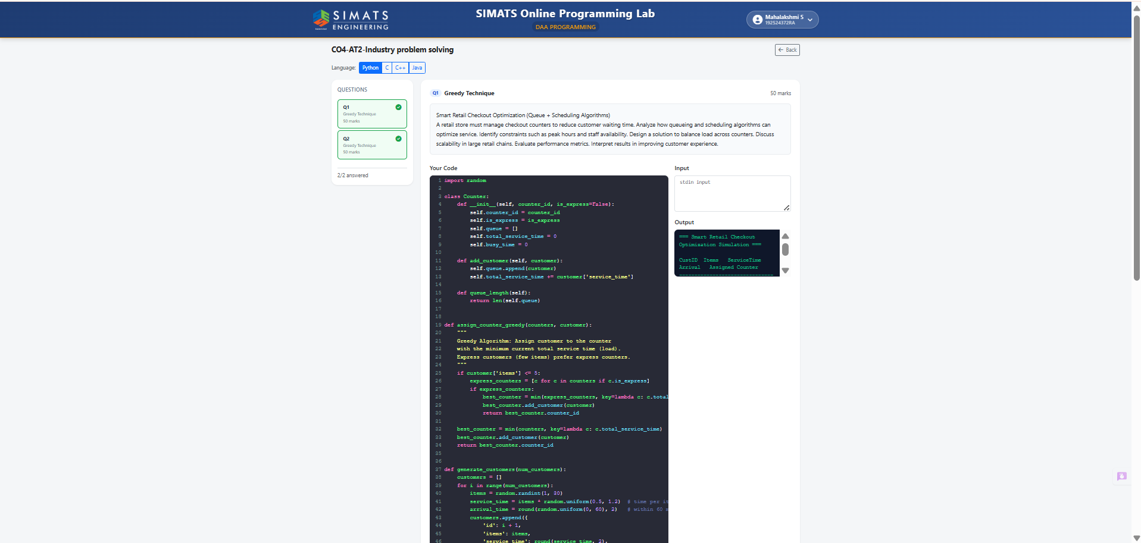

QUESTION 2:
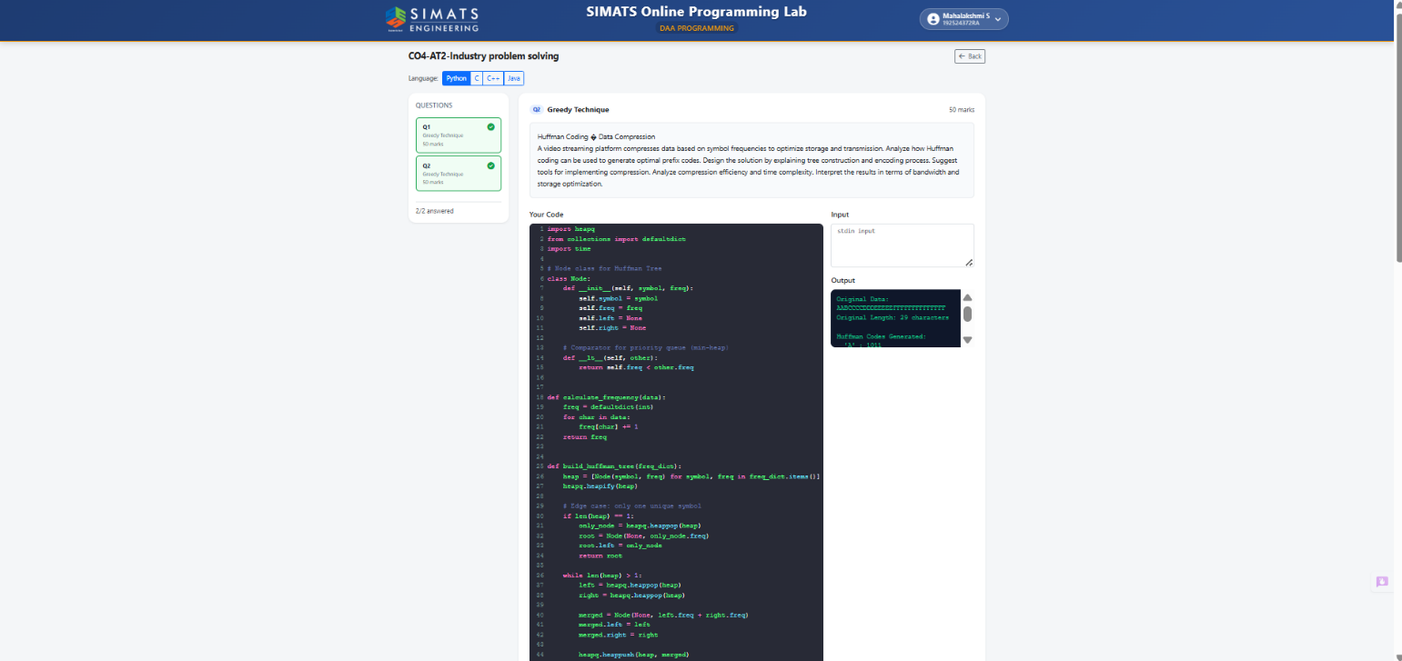

Code of Conduct
I S.MAHALAKSHMI(192524372)__________________________ (Name / Reg No) certify that this submission is my original work and that I have adhered to the guidelines specified for this assessment. I understand that any violation of academic integrity rules will result in disciplinary action.
Signature of the Student:S.MAHALAKSHMI _________________________

RUBRICS FOR CALCULATION
Industry Problem Solving Task

Criteria | Weightage | Level 4 – Exemplary | Level 3 – Proficient | Level 2 – Developing | Level 1 – Beginning
Understanding of Industry Problem | 20% | Comprehensive understanding of real-world problem and constraints | Good understanding with minor gaps in requirements | Basic understanding; some requirements unclear | Poor understanding; misinterprets problem context
Application of Engineering Concepts | 25% | Applies advanced and relevant concepts effectively to solve the problem | Applies appropriate concepts with minor errors | Limited application of concepts | Incorrect or no application of concepts
Solution Design | 25% | Innovative, practical, and feasible solution aligned with industry standards | Logical and feasible solution with minor gaps | Basic solution with limited feasibility | Unclear or impractical solution
Use of Tools | 15% | Effective use of modern tools, technologies, and real data | Appropriate use of tools with correct implementation | Limited or inconsistent use of tools | Minimal or incorrect use of tools
Analysis | 10% | Thorough analysis with validated results and performance evaluation | Good analysis with reasonable validation | Basic analysis with limited validation | Poor or no analysis
Professionalism | 5% | Highly professional, well-documented, and clearly presented work | Good documentation and presentation | Basic documentation with some gaps | Poor documentation and presentation

Mark Evaluation:
Case Study | Understanding of Industry Problem  (20) |  | Application of Engineering Concepts (25) | Solution Design  (25) | Use of Tools  (15) | Analysis (10) | Professionalism  (5) | Total Marks  (Each - 50)
Q1
Q2
 |  | Overall Total (100)

Faculty In-charge | Course Coordinator | Head of Department
Name: __________________  Signature: _______________ | Signature: _______________ | Signature: _______________
Date: ___________________ | Date: ___________________ | Date: ___________________

